**Camera**

Исходный код проекта:

<https://github.com/verkhoumov/AndroidLabs/tree/master/Camera>

Скриншоты экрана:

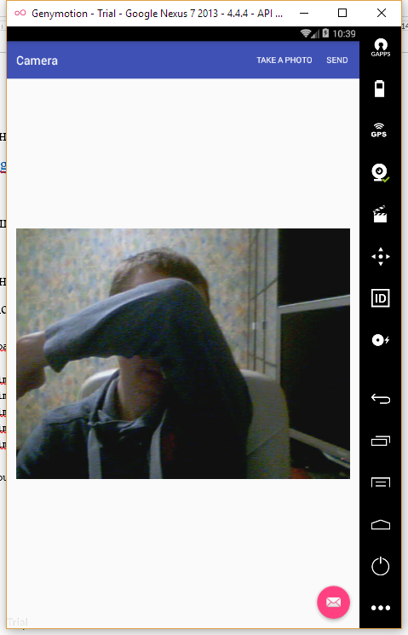

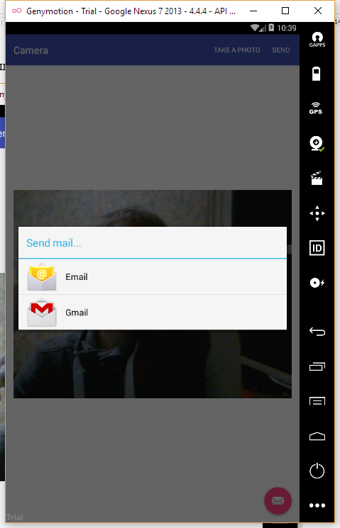

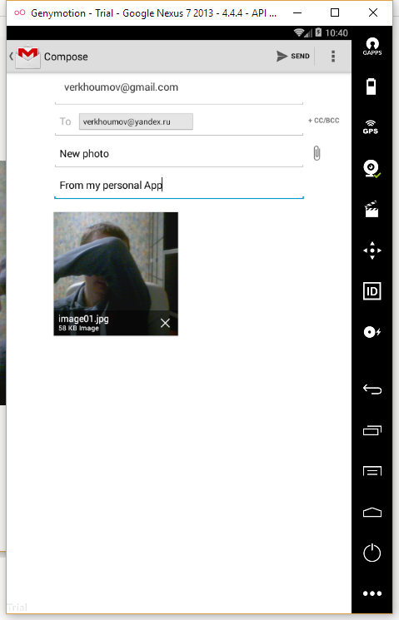

Исходный код.

MainActivity.java:

1. **package** ru.verkhoumov.camera;
3. **import** android.content.Intent;
4. **import** android.net.Uri;
5. **import** android.os.Bundle;
6. **import** android.os.Environment;
7. **import** android.provider.MediaStore;
8. **import** android.support.design.widget.FloatingActionButton;
9. **import** android.support.design.widget.Snackbar;
10. **import** android.support.v7.app.AppCompatActivity;
11. **import** android.support.v7.widget.Toolbar;
12. **import** android.util.Log;
13. **import** android.view.View;
14. **import** android.view.Menu;
15. **import** android.view.MenuItem;
16. **import** android.widget.ImageView;
17. **import** android.widget.Toast;
19. **import** java.io.File;
21. **public** **class** MainActivity **extends** AppCompatActivity {
22. **private** **static** **final** **int** CAPTURE_IMAGE_ACTIVITY_REQUEST_CODE = 100;
23. **private** **static** **final** String FILE_NAME = "image01.jpg";
24. **private** Uri fileUri;
26. File pictureDir = **new** File(
27. Environment.getExternalStoragePublicDirectory(Environment.DIRECTORY_PICTURES),
28. "CameraDemo"
29. );
31. @Override
32. **protected** **void** onCreate(Bundle savedInstanceState) {
33. **super**.onCreate(savedInstanceState);
34. setContentView(R.layout.activity_main);
35. Toolbar toolbar = (Toolbar) findViewById(R.id.toolbar);
36. setSupportActionBar(toolbar);
38. *// Если каталог под изображение отсутствует, создаём его.*
39. **if** (!pictureDir.exists()) {
40. pictureDir.mkdirs();
41. }
43. FloatingActionButton fab = (FloatingActionButton) findViewById(R.id.fab);
44. fab.setOnClickListener(**new** View.OnClickListener() {
45. @Override
46. **public** **void** onClick(View view) {
47. Snackbar.make(view, "Replace with your own action", Snackbar.LENGTH_LONG)
48. .setAction("Action", **null**).show();
49. }
50. });
51. }
53. @Override
54. **public** **boolean** onCreateOptionsMenu(Menu menu) {
55. *// Inflate the menu; this adds items to the action bar if it is present.*
56. getMenuInflater().inflate(R.menu.menu_main, menu);
57. **return** **true**;
58. }
60. @Override
61. **public** **boolean** onOptionsItemSelected(MenuItem item) {
62. **switch** (item.getItemId()) {
63. **case** R.id.action_camera:
64. showCamera();
65. **return** **true**;
66. **case** R.id.action_email:
67. emailPicture();
68. **return** **true**;
69. **default**:
70. **return** **super**.onContextItemSelected(item);
71. }
72. }
74. **private** **void** showCamera() {
75. File image = **new** File(pictureDir, FILE_NAME);
76. fileUri = Uri.fromFile(image);
78. Intent intent = **new** Intent(MediaStore.ACTION_IMAGE_CAPTURE);
79. intent.putExtra(MediaStore.EXTRA_OUTPUT, fileUri);
81. *// Проверка наличия камеры на устройстве.*
82. **if** (intent.resolveActivity(getPackageManager()) != **null**) {
83. startActivityForResult(intent, CAPTURE_IMAGE_ACTIVITY_REQUEST_CODE);
84. } **else** {
85. Log.d("Camera", "Camera is not exists");
86. }
87. }
89. **private** **void** emailPicture() {
90. Intent emailIntent = **new** Intent(Intent.ACTION_SEND);
92. emailIntent.setType("application/image");
93. emailIntent.putExtra(Intent.EXTRA_EMAIL, **new** String[] {"verkhoumov@yandex.ru"});
94. emailIntent.putExtra(Intent.EXTRA_SUBJECT, "New photo");
95. emailIntent.putExtra(Intent.EXTRA_TEXT, "From my personal App");
96. emailIntent.putExtra(Intent.EXTRA_STREAM, fileUri);
98. startActivity(Intent.createChooser(emailIntent, "Send mail..."));
99. }
101. @Override
102. **protected** **void** onActivityResult(**int** requestCode, **int** resultCode, Intent data) {
103. **if** (requestCode == CAPTURE_IMAGE_ACTIVITY_REQUEST_CODE) {
104. **if** (resultCode == RESULT_OK) {
105. File image = **new** File(pictureDir, FILE_NAME);
106. fileUri = Uri.fromFile(image);
108. ImageView imageView = (ImageView) findViewById(R.id.imageView);
109. imageView.setImageURI(fileUri);
110. } **else** **if** (resultCode == RESULT_CANCELED) {
111. Toast
112. .makeText(**this**, "Action cancelled", Toast.LENGTH_SHORT)
113. .show();
114. } **else** {
115. Toast
116. .makeText(**this**, "Error", Toast.LENGTH_SHORT)
117. .show();
118. }
119. }
120. }
121. }

AndroidManifest.xml:

1. **<?xml** version="1.0" encoding="utf-8"**?>**
2. **<manifest** xmlns:android="http://schemas.android.com/apk/res/android"
3. package="ru.verkhoumov.camera"**>**
5. **<uses-feature** android:name="android.hardware.camera" **/>**
6. **<uses-permission** android:name="android.permission.CAMERA" **/>**
7. **<uses-permission** android:name="android.permission.WRITE_EXTERNAL_STORAGE" **/>**
9. **<application**
10. android:allowBackup="true"
11. android:icon="@mipmap/ic_launcher"
12. android:label="@string/app_name"
13. android:supportsRtl="true"
14. android:theme="@style/AppTheme"**>**
15. **<activity**
16. android:name=".MainActivity"
17. android:label="@string/app_name"
18. android:theme="@style/AppTheme.NoActionBar"**>**
19. **<intent-filter>**
20. **<action** android:name="android.intent.action.MAIN" **/>**
22. **<category** android:name="android.intent.category.LAUNCHER" **/>**
23. **</intent-filter>**
24. **</activity>**
25. **</application>**
26. **</manifest>**

content_main.xml:

1. **<?xml** version="1.0" encoding="utf-8"**?>**
2. **<RelativeLayout** xmlns:android="http://schemas.android.com/apk/res/android"
3. xmlns:app="http://schemas.android.com/apk/res-auto"
4. xmlns:tools="http://schemas.android.com/tools"
5. android:layout_width="match_parent"
6. android:layout_height="match_parent"
7. android:paddingBottom="@dimen/activity_vertical_margin"
8. android:paddingLeft="@dimen/activity_horizontal_margin"
9. android:paddingRight="@dimen/activity_horizontal_margin"
10. android:paddingTop="@dimen/activity_vertical_margin"
11. app:layout_behavior="@string/appbar_scrolling_view_behavior"
12. tools:context="ru.verkhoumov.camera.MainActivity"
13. tools:showIn="@layout/activity_main"**>**
15. **<ImageView**
16. android:id="@+id/imageView"
17. android:layout_width="match_parent"
18. android:layout_height="match_parent" **/>**
19. **</RelativeLayout>**

menu_main.xml:

1. **<menu** xmlns:android="http://schemas.android.com/apk/res/android"
2. xmlns:app="http://schemas.android.com/apk/res-auto"
3. xmlns:tools="http://schemas.android.com/tools"
4. tools:context="ru.verkhoumov.camera.MainActivity"**>**
6. **<item**
7. android:id="@+id/action_camera"
8. android:orderInCategory="100"
9. app:showAsAction="ifRoom"
10. android:title="@string/action_show_camera" **/>**
12. **<item**
13. android:id="@+id/action_email"
14. android:orderInCategory="200"
15. app:showAsAction="ifRoom"
16. android:title="@string/action_email" **/>**
17. **</menu>**